Wilbur Wright College
CIS114 – Mobile Applications

Prof. Gustavo Alatta Student name: ________________________________________
Lab5

Objectives: The main objective of this lab is to measure your expertise using the main user interfaces of Android Studio,(such ImageView, ImageButton), Class creation, instantiation, ListView, ArrayAdapter class, Web Activity, and Collection manipulation.

Deliverables:
- A MS Word document (use this Word document) with the following:
  - The screenshot of your final product.
  - Copy of your XML (contain_main.xml)
Procedure:
- Create an Application call “My Favorite City” using Empty activity.
- Download the zip folder with images, and city information.
- Using the information provided by the Instructor design your ListView design (similar to the in class design)
- Your activity_main must look like this:

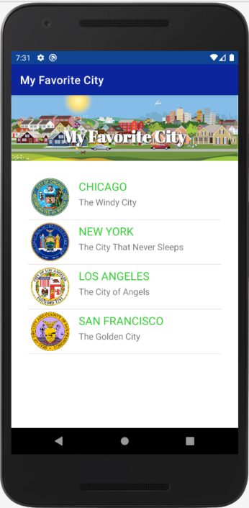
- Implement a class (call it CustomList Adapter) to extend the ArrayAdapter class.
- Your main activity must have 4 arrays: name, nickname, imgid, and webaddress.
- In the Oncreate method design the dapter (create and instance of the CustomListAdapter) the, set the adapter.
- Set the setOnItemClickListener and start an activity to launch the city website. Hint:
startActivity(new Intent(Intent.ACTION_VIEW, Uri.parse(“http://address.com)));
use an extra array for this.

- These are the result after you click each list:

